**Download data from RMS**

This is how we download specific information from RMS application in v16. This is using the Template Management framework in v15 and onwards.

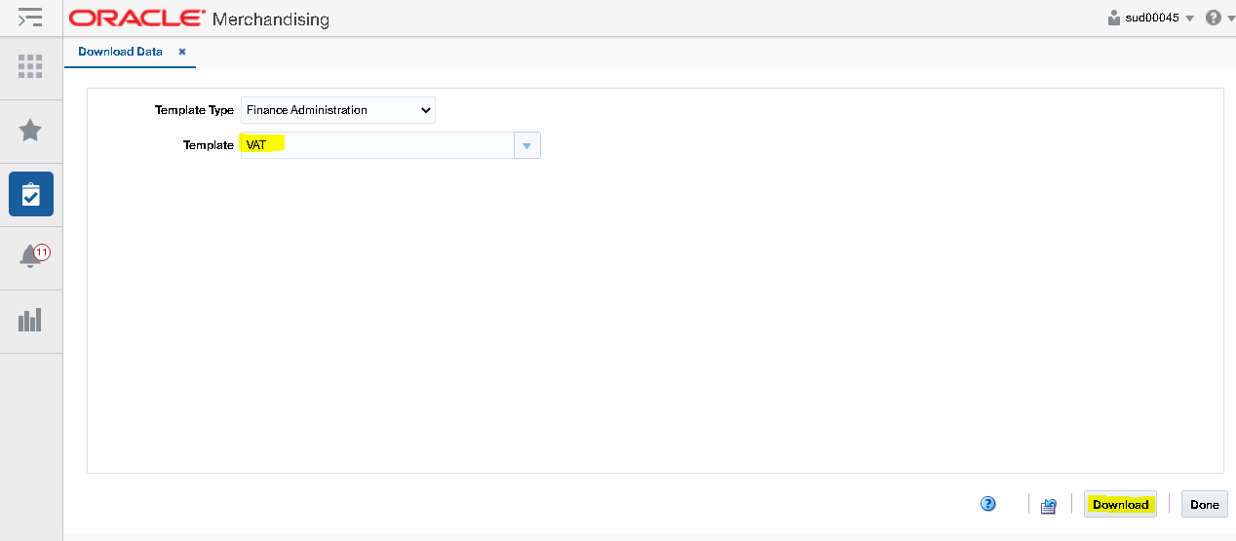

This how the downloaded data in a spreadsheet looks like:

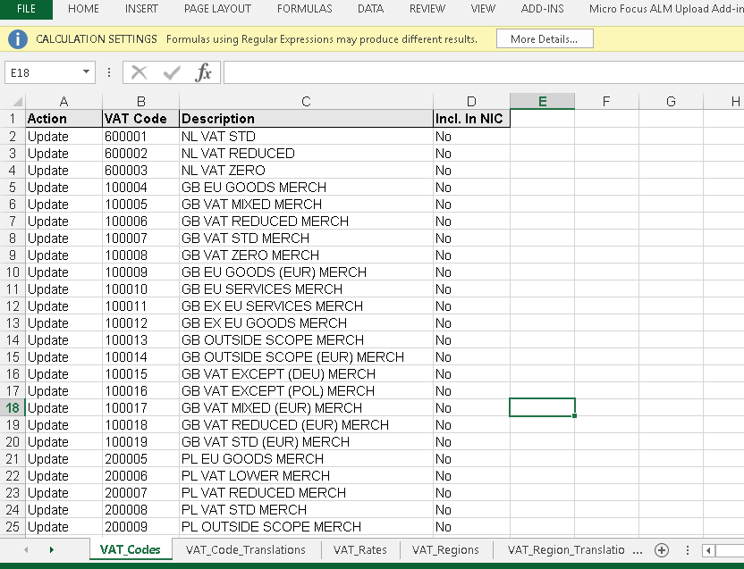

Downloaded file below for reference:



Below is the package and the specific function (i.e. CREATE_S9T) that contains the implementation details on how the VAT data is queried and written into a file.

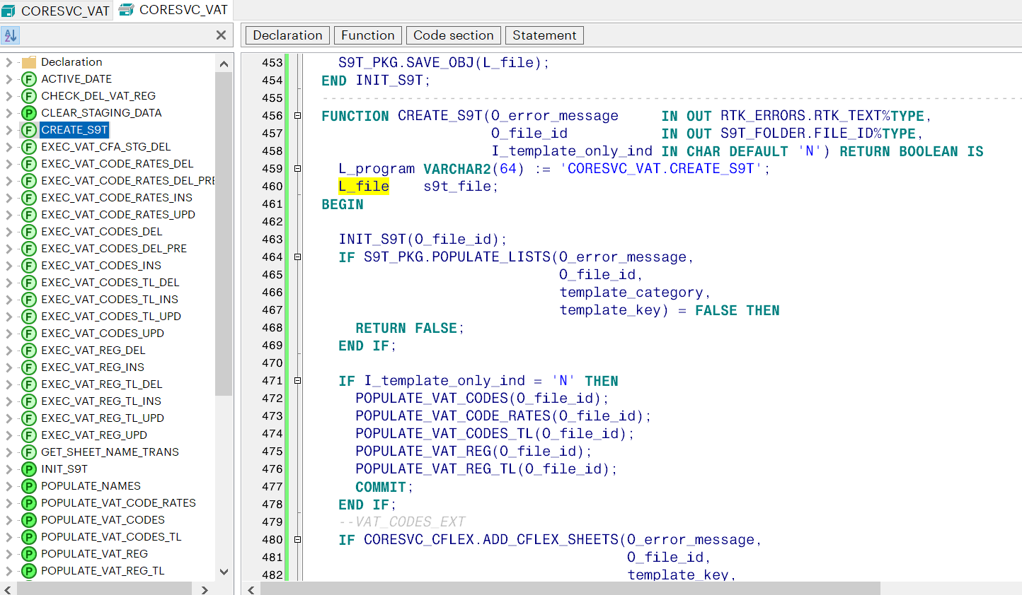

**Example of Download Data from a custom sql using the base Template Management framework**

Create the below entries in the **s9t_\*** tables:

**SELECT** * **FROM** s9t_template **WHERE** template_key = 'TJX_UC_ADJ_UPLD'; *--CHANGE TEMPLATE_TYPE BACK TO PODT*

|  |  |  |  |  |  |  |  |
| --- | --- | --- | --- | --- | --- | --- | --- |
| **TEMPLATE_KEY** | **TEMPLATE_NAME** | **TEMPLATE_DESC** | **FILE_ID** | **CREATE_ID** | **CREATE_DATETIME** | **TEMPLATE_TYPE** | **TEMPLATE_CATEGORY** |
| TJX_UC_ADJ_UPLD | Unit and Cash Adjustment Upload | Unit and Cash Adjustment Upload for TJX | 1 | TJX_RMS13EU | 09-Oct-2019 05:44:24 PM | RMSFCO |  |

**SELECT** * **FROM** s9t_tmpl_wksht_def **WHERE** template_key = 'TJX_UC_ADJ_UPLD';

|  |  |  |  |  |
| --- | --- | --- | --- | --- |
| **TEMPLATE_KEY** | **WKSHT_KEY** | **WKSHT_NAME** | **MANDATORY** | **SEQ_NO** |
| TJX_UC_ADJ_UPLD | TJX_UC_ADJ | TJX_UC_ADJ | Y | 1 |

**SELECT** * **FROM** s9t_tmpl_cols_def **WHERE** template_key = 'TJX_UC_ADJ_UPLD';

| **TEMPLATE_KEY** | **WKSHT_KEY** | **COLUMN_KEY** | **COLUMN_NAME** | **MANDATORY** | **CREATE_ID** | **CREATE_DATETIME** | **LAST_UPDATE_ID** | **LAST_UPDATE_DATETIME** | **DEFAULT_VALUE** | **REQUIRED_VISUAL_IND** |
| --- | --- | --- | --- | --- | --- | --- | --- | --- | --- | --- |
| TJX_UC_ADJ_UPLD | TJX_UC_ADJ | ADJ_NUMBER | ADJ_NUMBER | Y | TJX_RMS13EU | 09-OCT-19 05.44.24.000000 PM | TJX_RMS13EU | 09-OCT-19 05.44.24.000000 PM |  | Y |
| TJX_UC_ADJ_UPLD | TJX_UC_ADJ | DEPT | DEPT | Y | TJX_RMS13EU | 09-OCT-19 05.44.24.000000 PM | TJX_RMS13EU | 09-OCT-19 05.44.24.000000 PM |  | Y |
| TJX_UC_ADJ_UPLD | TJX_UC_ADJ | TJX_STYLE | TJX_STYLE | Y | TJX_RMS13EU | 09-OCT-19 05.44.24.000000 PM | TJX_RMS13EU | 09-OCT-19 05.44.24.000000 PM |  | Y |
| TJX_UC_ADJ_UPLD | TJX_UC_ADJ | REASON | REASON | Y | TJX_RMS13EU | 09-OCT-19 05.44.24.000000 PM | TJX_RMS13EU | 09-OCT-19 05.44.24.000000 PM |  | N |
| TJX_UC_ADJ_UPLD | TJX_UC_ADJ | QTY | QTY | Y | TJX_RMS13EU | 09-OCT-19 05.44.24.000000 PM | TJX_RMS13EU | 09-OCT-19 05.44.24.000000 PM |  | N |
| TJX_UC_ADJ_UPLD | TJX_UC_ADJ | RETAIL | RETAIL | Y | TJX_RMS13EU | 09-OCT-19 05.44.24.000000 PM | TJX_RMS13EU | 09-OCT-19 05.44.24.000000 PM |  | Y |
| TJX_UC_ADJ_UPLD | TJX_UC_ADJ | LOCATION | LOCATION | Y | TJX_RMS13EU | 09-OCT-19 05.44.24.000000 PM | TJX_RMS13EU | 09-OCT-19 05.44.24.000000 PM |  | N |
| TJX_UC_ADJ_UPLD | TJX_UC_ADJ | VENDOR_ORDER_NO | VENDOR_ORDER_NO | Y | TJX_RMS13EU | 09-OCT-19 05.44.24.000000 PM | TJX_RMS13EU | 09-OCT-19 05.44.24.000000 PM |  | Y |
| TJX_UC_ADJ_UPLD | TJX_UC_ADJ | PROCESSING_AREA | PROCESSING_AREA | Y | TJX_RMS13EU | 09-OCT-19 05.44.24.000000 PM | TJX_RMS13EU | 09-OCT-19 05.44.24.000000 PM | EG | N |
| TJX_UC_ADJ_UPLD | TJX_UC_ADJ | KTR_NUM | KTR_NUM | Y | TJX_RMS13EU | 09-OCT-19 05.44.24.000000 PM | TJX_RMS13EU | 09-OCT-19 05.44.24.000000 PM |  | Y |
| TJX_UC_ADJ_UPLD | TJX_UC_ADJ | LANDED_COST | LANDED_COST | Y | TJX_RMS13EU | 09-OCT-19 05.44.24.000000 PM | TJX_RMS13EU | 09-OCT-19 05.44.24.000000 PM |  | Y |
| TJX_UC_ADJ_UPLD | TJX_UC_ADJ | STATUS | STATUS | N | TJX_RMS13EU | 09-OCT-19 06.24.55.000000 PM | TJX_RMS13EU | 09-OCT-19 06.24.55.000000 PM | N | N |

**SELECT** * **FROM** SVC_TMPL_API_MAP **WHERE** template_key **IN** ('TJX_UC_ADJ_UPLD');

|  |  |  |  |
| --- | --- | --- | --- |
| **TEMPLATE_KEY** | **DNLD_API** | **UPLD_API** | **PROCESS_API** |
| TJX_UC_ADJ_UPLD | CORESVC_UCADJ.CREATE_S9T | CORESVC_UCADJ.CREATE_S9T | CORESVC_UCADJ.CREATE_S9T |

Create the below package (body and specs) under TJX_RMS13EU schema

CREATE OR REPLACE PACKAGE TJX_RMS13EU.CORESVC_UCADJ AUTHID CURRENT_USER AS

template_key CONSTANT VARCHAR2(255) := 'TJX_UC_ADJ_UPLD';

template_category CONSTANT VARCHAR2(255) := 'RMSFIN';

action_new VARCHAR2(25) := 'NEW';

action_mod VARCHAR2(25) := 'MOD';

action_del VARCHAR2(25) := 'DEL';

UCADJ_sheet VARCHAR2(255) := 'TJX_UC_ADJ';

TJX_UC_ADJ$Action NUMBER := 1;

TJX_UC_ADJ$ADJ_NUMBER NUMBER := 2;

TJX_UC_ADJ$DEPT NUMBER := 3;

TJX_UC_ADJ$TJX_STYLE NUMBER := 4;

TJX_UC_ADJ$REASON NUMBER := 5;

TJX_UC_ADJ$QTY NUMBER := 6;

TJX_UC_ADJ$RETAIL NUMBER := 7;

TJX_UC_ADJ$LOCATION NUMBER := 8;

TJX_UC_ADJ$VENDOR_ORDER_NO NUMBER := 9;

TJX_UC_ADJ$PROCESSING_AREA NUMBER := 10;

TJX_UC_ADJ$KTR_NUM NUMBER := 11;

TJX_UC_ADJ$LANDED_COST NUMBER := 12;

TJX_UC_ADJ$STATUS NUMBER := 13;

action_column VARCHAR2(255) := 'ACTION';

TYPE UCADJ_rec_tab IS TABLE OF tjx_uc_adj%ROWTYPE;

sheet_name_trans S9T_PKG.trans_map_typ;

-------------------------------------------------------------------------------------------------------

FUNCTION CREATE_S9T(O_error_message IN OUT RTK_ERRORS.RTK_TEXT%TYPE,

O_file_id IN OUT S9T_FOLDER.FILE_ID%TYPE,

I_template_only_ind IN CHAR DEFAULT 'N') RETURN BOOLEAN;

--------------------------------------------------------------------------------------------------------

END CORESVC_UCADJ;

/

CREATE OR REPLACE PACKAGE BODY TJX_RMS13EU.CORESVC_UCADJ AS

PROCEDURE INIT_S9T(O_file_id IN OUT NUMBER) IS

L_file s9t_file;

L_file_name s9t_folder.file_name%TYPE;

BEGIN

L_file := NEW s9t_file();

O_file_id := s9t_folder_seq.NEXTVAL;

L_file.file_id := O_file_id;

L_file_name := template_key || '_' || GET_USER || '_' ||

SYSDATE || '.ods';

L_file.file_name := L_file_name;

L_file.template_key := template_key;

L_file.user_lang := GET_USER_LANG;

L_file.add_sheet(UCADJ_sheet);

L_file.sheets(L_file.get_sheet_index(UCADJ_sheet)).column_headers := S9T_CELLS('ACTION',

'ADJ_NUMBER',

'DEPT',

'TJX_STYLE',

'REASON',

'QTY',

'RETAIL',

'LOCATION',

'VENDOR_ORDER_NO',

'PROCESSING_AREA',

'KTR_NUM',

'LANDED_COST',

'STATUS');

S9T_PKG.SAVE_OBJ(L_file);

END INIT_S9T;

----------------------------------------------------------------

PROCEDURE POPULATE_UCADJ(I_file_id IN NUMBER) IS

BEGIN

INSERT INTO TABLE

(SELECT ss.s9t_rows

FROM s9t_folder sf, TABLE(sf.s9t_file_obj.sheets) ss

WHERE sf.file_id = I_file_id

AND ss.sheet_name = UCADJ_sheet)

SELECT s9t_row(s9t_cells(CORESVC_UCADJ.action_mod,

ADJ_NUMBER,

DEPT,

TJX_STYLE,

REASON,

QTY,

RETAIL,

LOCATION,

VENDOR_ORDER_NO,

PROCESSING_AREA,

KTR_NUM,

LANDED_COST,

STATUS))

FROM tjx_uc_adj WHERE status = 'A';

END POPULATE_UCADJ;

----------------------------------------------------------------------

FUNCTION CREATE_S9T(O_error_message IN OUT RTK_ERRORS.RTK_TEXT%TYPE,

O_file_id IN OUT S9T_FOLDER.FILE_ID%TYPE,

I_template_only_ind IN CHAR DEFAULT 'N') RETURN BOOLEAN IS

L_program VARCHAR2(64) := 'CORESVC_UCADJ.CREATE_S9T';

L_file s9t_file;

BEGIN

INIT_S9T(O_file_id);

/*IF S9T_PKG.POPULATE_LISTS(O_error_message,

O_file_id,

template_category,

template_key) = FALSE THEN

RETURN FALSE;

END IF;*/

IF I_template_only_ind = 'N' THEN

POPULATE_UCADJ(O_file_id);

COMMIT;

END IF;

S9T_PKG.APPLY_TEMPLATE(O_file_id, template_key);

L_file := S9T_FILE(O_file_id);

IF S9T_PKG.CODE2DESC(O_error_message, template_category, L_file) =

FALSE THEN

RETURN FALSE;

END IF;

S9T_PKG.SAVE_OBJ(L_file);

S9T_PKG.UPDATE_ODS(L_file);

RETURN TRUE;

EXCEPTION

WHEN OTHERS THEN

O_error_message := SQL_LIB.CREATE_MSG('PACKAGE_ERROR',

SQLERRM,

L_program,

TO_CHAR(SQLCODE));

RETURN FALSE;

END CREATE_S9T;

-------------------------------------------------------------

END CORESVC_UCADJ;

/

Files below reference in .sql and .pck formats

 

Next, grant **execute** permission and create **public synonyms** for the above package:

GRANT **EXECUTE** ON CORESVC_UCADJ TO PUBLIC;

CREATE **PUBLIC SYNONYM** CORESVC_UCADJ FOR CORESVC_UCADJ;

Navigate to RMS v16 🡪 Tasks 🡪 Foundation Data 🡪 Data Loading Screen.

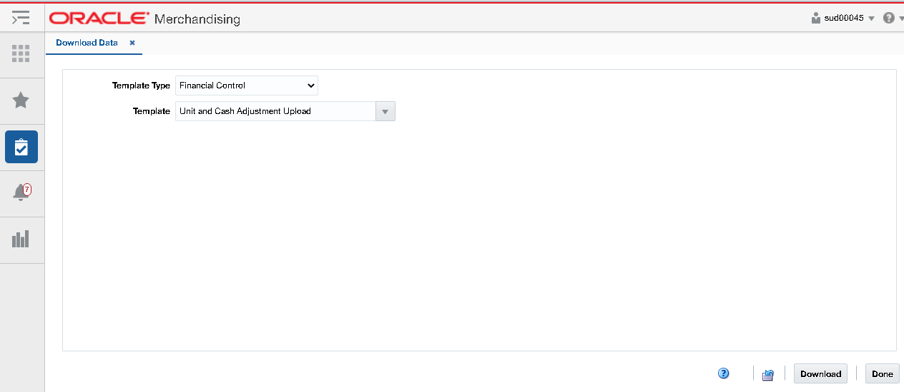

Select Template Type as “Financial Control” and template as Unit and Cash Adjustment (see above).

Click Download. The below .ods file should be created that contains approved uploaded Unit and Cash Adjustment records

